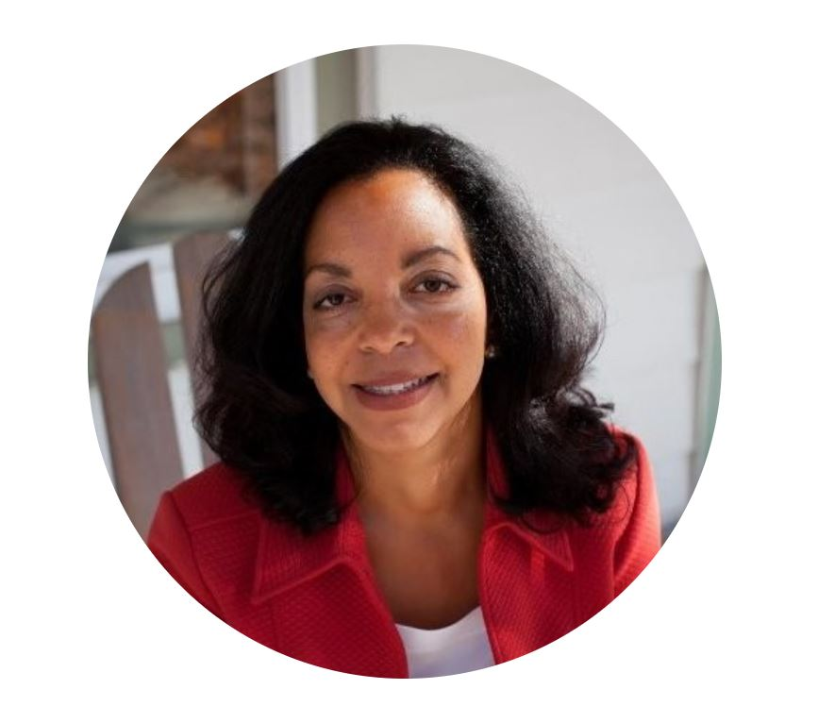Antoinette DuBois Ayers is a certified professional coach, master facilitator, and exceptional speaker with more than 20 years’ experience as an Executive Coach, Coach Trainer, and Master Facilitator in the field of Equity, Diversity & Inclusion.

Antoinette earned her Certified Professional Co-Active Coach (CPCC) Certification from the Coaches Training Institute and was an original member of the World Association of Business Coaches (WABC), where she co-developed an international coaching certification program, the Registered Corporate Coach (RCC), as the first National Director of Training.

Antoinette has helped a diverse array of organizations, teams, and individuals in the financial, healthcare, and nonprofit fields reach peak performance through leadership development, team building, engaging with diversity, and work-life integration. She is co-author of a best-selling book, The Coaching Conversation.

Among her several professional accomplishments, Ayers designed and facilitated a coaching clinic and talent management program for mid- to upper-level management at a Fortune 500 Company – an endeavor that garnered national recognition from Training Magazine's “Top 100.” ​
Antoinette believes in creating vision and making it a reality. She’s the founder of DuBois Ayers Coaching, a certified minority- woman-owned business. Ayers is also a co-founder of the International Stillbirth Alliance, now recognized by the World Health Organization with conferences held in over 16 countries. Additionally, she co-founded

Bridge Communications of Chicago, Illinois, Community Health IT of North Central Florida, and the Healthy Living and Learning Center of Petersburg, Virginia.

Ayers has a heart for public service, exemplified through her involvement as past Board Chair of the International Stillbirth Alliance and past Board Member of First Candle. She is also an original and honorary lifetime member of the World Association of Business Coaches (WABC), where she co-developed an international coaching certification program, the Registered Corporate Coach (RCC), as the first National Director of Training.

She obtained a Bachelor of Science degree from Northern Illinois University and a Certified Professional Co-Active Coach (CPCC) Certification from the Coaches Training Institute. Ayers is also a Registered Corporate Coach Instructor.

When Ayers is not serving others at work or in the community, she is completing her QiGong instructor’s certification. She enjoys teaching QiGong for nonprofit health related organizations, developing her hot yoga practice, and river rock hopping with her children.

